Christa Noel Robbins

29 Marion Ave. #6

Pasadena, CA 91106

[christa.robbins@gmail.com](mailto:christa.robbins@gmail.com)

**Hofmann, Hans (1880-1966) Word Count 530**

Hans Hofmann was a German-American painter associated with Abstract Expressionism. Known as much for his paintings as for his role as a teacher, Hofmann moved to New York City in 1932. Much older than the core group of New York School painters, Hofmann acted as a kind of bridge between European and American modernism. Hofmann’s paintings are highly recognisable for the manner in which they feature large planes of thickly applied, bold colour, often interspersed with expressionistic fields of gestural painting. The result, which can be seen in his 1962 painting *Memoria in Aeternum,* is a dynamic play with depth of field and colour relations. Hofmann referred to this spatial and optical play as the “push-pull” effect (indicating the manner in which areas of a canvas can appear to push back behind the picture plane and pull forward into the viewer’s space, while simultaneous reading as flat surface). The spatial and material relationality introduced through this device influenced a generation of New York painters and critics who were taught directly by Hofmann or were told of his theories through second parties. It was in his school that many of their first lessons in modernist painting were encountered. Hofmann’s students from this period include Lee Krasner, Helen Frankenthaler, Frank Stella, Allan Kaprow and, importantly, Clement Greenberg.

Hofmann lived in Paris from 1903 to 1914, a formative period for modernist painting and Hofmann alike. It was in Paris that Hofmann had contact with the founders of Cubism—Picasso and Braque, as well as Leger and Delauney—and Fauvism and began painting in a highly chromatic, decorative fashion. Not long after returning to Munich, Hofmann opened his first art school in 1915, initiating his long career as an art instructor. Upon his arrival in New York City, Hofmann began teaching at the Art Students League before opening his own school in 1933. Hofmann was concerned in Munich and New York alike to share what he learned from the Parisian painters and to promote a particularly modernist mode of painting, which emphasised the “plastic” content of the visual arts. Demonstrations of his influence on the direction painting was to take in the U.S. are to be found in Hofmann’s early drip paintings, which would come to influence Jackson Pollock (who was exposed to Hofmann through his wife Lee Krasner), and his emphasis on enunciating the picture plane as an expression of medium specificity, a key tenet in Greenberg’s theory of modernism. In 1957 Hofmann was awarded a retrospective at the Whitney Museum of American Art and in 1958 closed his school in order to dedicate his time more fully to painting. In 1960, by then in his early eighties, Hofmann was one of four artists chosen to represent the U.S. in Venice Biennale.

**References and Further Reading:**

<http://www.hanshofmann.org/>

Greenberg, C. (1955) “Introduction to an Exhibition on Hans Hofmann.” Reprinted in

*Clement Greenberg the Collected Essays and Criticism*, Volume 3: Affirmations and Refusals, 1950-1956. Edited by John O’Brian. Chicago: University of Chicago Press, 1993.

Hofmann, H. (1967) *The Search for the Real and Other Essays*. Cambridge, MA: MIT Press.

Hunter, S. (2002) *Hans Hofmann*. New York: Rizzoli.

Seitz, W. (1963) *Hans Hofmann*. New York: Double Day & Company, Inc.

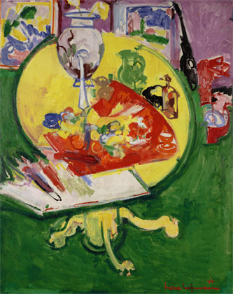

Hans Hofmann, *Yellow Table on Green* 1936. Oil on board. 60 x 47 1/2 inches (152.4 x 120.65 cm) Collection Dallas Museum of Art, fractional gift of The Rachofsky Collection in honor of Dr. Dorothy Kosinski, the Barbara Thomas Lemmon Curator of European Art. <http://www.dma.org/>

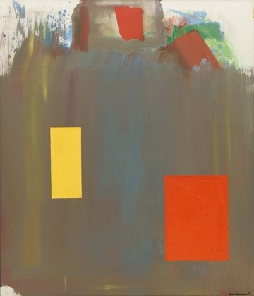

Hans Hofmann, *Memoria in Aeternum*, 1962. Oil on canvas. 7' x 6' 1/8" (213.3 x 183.2 cm). Museum of Modern Art, New York, NY.

<http://www.moma.org/collection/browse_results.php?criteria=O%3AAD%3AE%3A2698&page_number=9&template_id=1&sort_order=1>